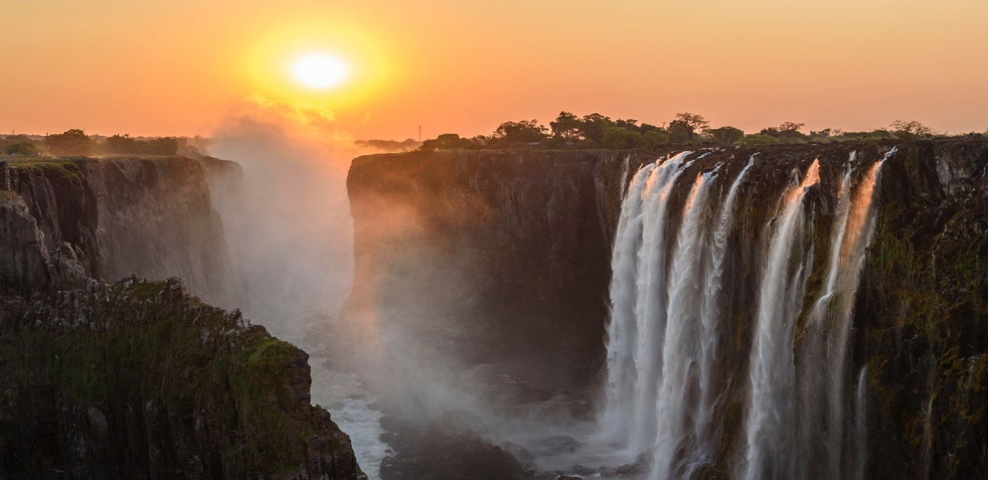

**Victoria Falls**

Victoria Falls, located on the border of Zambia and Zimbabwe, is one of the world's largest and most awe-inspiring waterfalls, known for its breathtaking beauty and the thunderous roar of its cascading waters.

**History**

Victoria Falls, located on the Zambezi River between Zambia and Zimbabwe, is one of the world's largest and most famous waterfalls, named after Queen Victoria by Scottish explorer David Livingstone in 1855.